Project Design Phase-II
Data Flow Diagram & User Stories

Date | 19 February 2026
Team ID (SkillWallet ID) | LTVIP2026TMIDS24279
Project Name | FreelanceFinder: Discovering Opportunities, Unlocking Potential
Maximum Marks | 4 Marks

Data Flow Diagrams:
A Data Flow Diagram (DFD) illustrates how data moves within the Freelance Finder platform. It captures how users (freelancers and clients) interact with the system, how information flows between different components, and where the data is stored.

DFD Level 0
External entities: Client, Freelancer, Admin, Payment Gateway
System: SB Works Platform (centralized)
High-level data flows:
- Client → SB Works: Post Project, Manage Posts, Make Payments, Chat
- Freelancer → SB Works: Browse Projects, Submit Bids, Upload Deliverables, Chat
- SB Works → Payment Gateway: Payment requests / confirmations
- Admin ↔ SB Works: Verification actions, moderation, analytics
One-sentence summary:
SB Works receives project posts and bids from clients and freelancers, facilitates messaging and file exchange, records transactions via a payment gateway, and provides admin tools for verification and moderation.

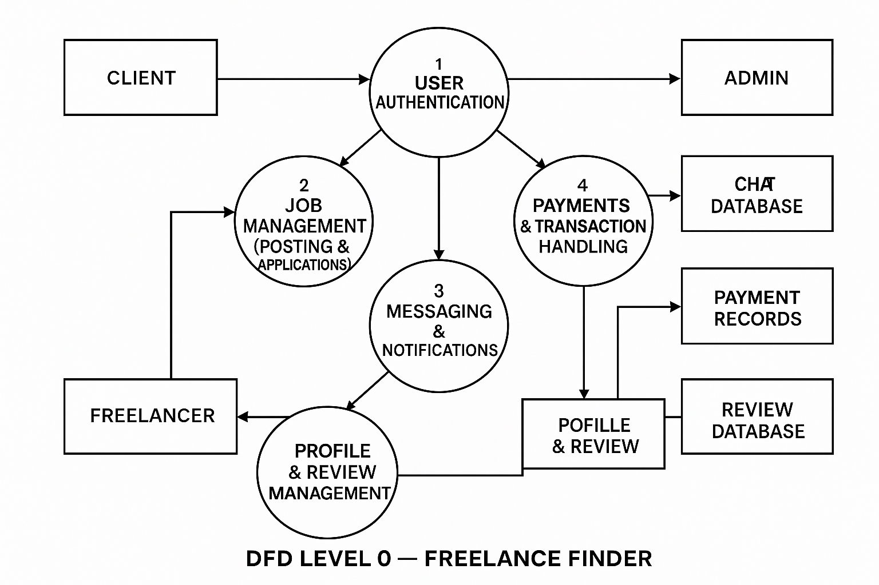

User Stories

User Story Table – Freelance Finder
User Type | Functional Requirement (Epic) | User Story / Task | Acceptance Criteria | Priority | Release
Client | User Authentication | As a client, I want to sign up and login so I can access my dashboard | Valid user is created; incorrect login returns error; JWT token is generated. | High | Sprint-1
Freelancer | User Authentication | As a freelancer, I want to sign up and log in so I can create my profile. | Freelancer role saved; dashboard accessible after login | High | Sprint-1
User (Client/Freelancer) | Account Recovery | As a user, I want to reset my password so I can recover my account. | Email sent; token validated; password successfully reset. | Medium | Sprint-2
Client | Project Posting | As a client, I want to post a new project with details so freelancers can apply. | . Project saved; visible in listings; validation works. | High | Sprint-1
Freelancer | Project Browsing | As a freelancer, I want to browse and filter projects so I can find relevant work. | Filters work; search returns correct results; pagination enabled. | High | Sprint-1
Freelancer | Bidding / Proposal | As a freelancer, I want to submit a proposal so clients can review my bid. | Proposal saved; client receives notification | High | Sprint-1
Client | Bid Management | As a client, I want to review proposals so I can select the best freelancer. | List of proposals visible; shortlist/accept options functional. | High | Sprint-1
Client/Freelancer | Real-Time Chat | As a user, I want to chat in real-time with the other party. | Messages delivered instantly; stored in DB; unread counts update. | Medium | Sprint-2
Freelancer | Profile & Portfolio | As a freelancer, I want to create my profile with skills & portfolio. | Profile fields saved; portfolio images uploaded | High | Sprint-2
User | Notifications | As a user, I want to receive alerts for messages, proposals, and approvals. | Notifications visible; can mark read; triggers work. | Medium | Sprint-2
Freelancer | Work Submission | As a freelancer, I want to upload deliverables when work is complete | File uploaded; client notified; version saved. | High | Sprint-2
Client | Work Review | As a client, I want to approve or request revisions for delivered work. | Status updates to Approved/Revision; freelancer notified. | High | Sprint-2
Client | Ratings & Reviews | As a client, I want to leave feedback so others can evaluate freelancers. | Review stored; average rating updated. | Medium | Sprint-3
Client | Payment Processing | As a client, I want to securely pay for the project. | Payment gateway works; transaction saved; confirmation sent | High | Sprint-3
Freelancer | Pay-out & Earnings | As a freelancer, I want to track my earnings and withdraw money. | Transaction history visible; payout request saved. | Medium | Sprint-3
Admin | User Verification | As an admin, I want to verify users to ensure platform trust. | Approve/reject options work; verification badge applied | High | Sprint-1
User | Project Bookmarking | As a user, I want to save projects to view later. | Bookmark saved; visible on dashboard | Medium | Sprint-3
System | System Logging | As a system, I must log important actions for security. | Logs stored for login, payment, posting | Medium | Sprint-1
Client/Freelancer | Dispute Management | As a user, I want to raise a dispute if there's an issue. | Dispute created; admin gets notified; status tracked. | High | Sprint-3

